Melle Dijkstra

Melle210202@gmail.com

9-12-2015

Description

This Detail Design will give in depth information about the front-end of this project.

Front-end Detail Design

Cheery

# Table of contents

1 Table of contents 1

2 Materialize 2

2.1 Components 2

2.1.1 Card 2

2.1.2 Collections 2

2.2 Installation 2

3 JQuery Framework 3

4 Asynchronous JavaScript and XML 4

5 The Flow 5

6 List of terms and abbreviations 6

# Materialize

Materialize is a modern responsive front-end framework based on Material Design from Google. It uses the same elements and functionality as the Google Material Design (MD). That way the users that are already familiar with the Material Design will find it easy to use the application and follow the flow it supposed to have.

## Components

Materialize has its own color palettes, grid system and components which are all styled and easy to use by calling a class name within your CSS. Here are some of the most used ones for this project:

### Card

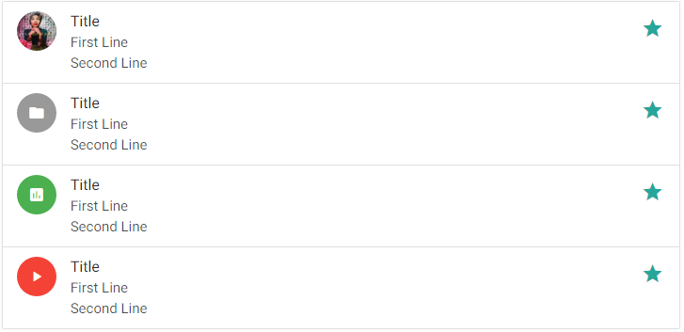A card is a sort of box or container where you can put text or images in to display as a group.

### Collections

The collections list can represent any type of information grouped together. It can be a friend list or a list of users found within Cheery.

## Installation

To install Materialize you have 2 options: Download a package with CSS and JavaScript code or the SASS version which needs a SASS compiler. For this project the first options is chosen because it’s easy and we don’t need a SASS compiler which takes more time to setup.

The Materialize package:

Materialize/

|--css/

| |--materialize.css

|

|--font/

| |--material-design-icons/

| |--roboto/

|

|--js/

| |--materialize.js

Materialize simplifies life for developers and the users they serve.

# JQuery Framework

The open-source JavaScript framework called jQuery is simple and easy to use in every type of application that’s why it’s included in the Cheery project.

# Asynchronous JavaScript and XML

Ajax is a term that describes a new approach to using a number of existing technologies together, including the following: HTML or XHTML, Cascading Style Sheets, JavaScript, the Document Object Model, XML, XSLT, and the XMLHttpRequest object.

Ajax can be used for a numerous of features on the site like a chat and notification system. However there are some drawbacks when using Ajax polling. It looks like you have a real time connection with another user or server but that’s not the case. With the Ajax polling technique you send a request in the background to the server in such a short time that it visually looks like you have a real time connection.

# The Flow

The flow of the front-end should look about the diagram but keeps changing when in development phase. Basically the most pages need the visitor to be logged in. Only some pages can be accessed by normal visitors who are not logged in like a user or group page. A user’s pages only contains information which the user himself has specified that normal visitors are able to see.

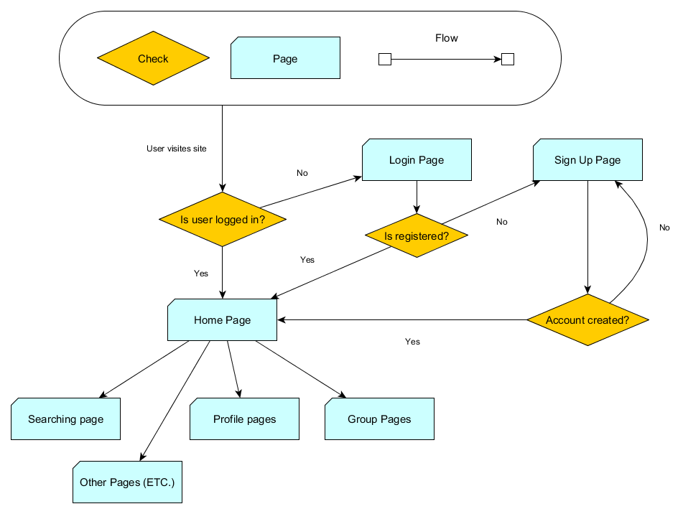

# List of terms and abbreviations

A list with terms and abbreviations is described here for the difficult words used in this document. The list is sorted alphabetically.

|  |  |
| --- | --- |
| *Term / Abbreviation* | *Description* |
| Back-end | The back-end is the location or place where the front-end communicates with. So a client (front-end) requests resources or operations from the back-end. The back-end is in most occasions the server. Back-end can also be the underlying code that executes when an event occurs in the front-end. |
| Front-end | The Front-end is the viewable/usable part of a system. This part is directly accessed by the user and allows easy use of the application. The front-end communicates with the back-end. |
| CSS | CSS (Cascading Style Sheet) is a style language that defines layout of HTML documents. For example, CSS covers fonts, colors, margins, lines, height, width, background images, advanced positions and many other things. |
| SASS | Sass is a powerful professional grade CSS extension language. |
| Compiler | A compiler is a computer program (or a set of programs) that transforms source code written in a programming language (the source language) into another computer language (the target language), with the latter often having a binary form known as object code. |